[https://www.quora.com/How-does-a-Google-image-search-engine-work#:~:text=There%20are%20a%20few%20mechanisms,working%20on%20indexing%20similar%20images.](https://www.quora.com/How-does-a-Google-image-search-engine-work" \l ":~:text=There%20are%20a%20few%20mechanisms,working%20on%20indexing%20similar%20images.)

**How does a Google image search engine work?**

There are a few mechanisms at by that drive Google Image Search. Google can look at a variety of sources for information to determine what an image is, for example: indexing the text around a word, indexing the image file name. and google is working on indexing similar images. With all of this information Google Search can essentially “see” similarities between images and create accurate image search results.

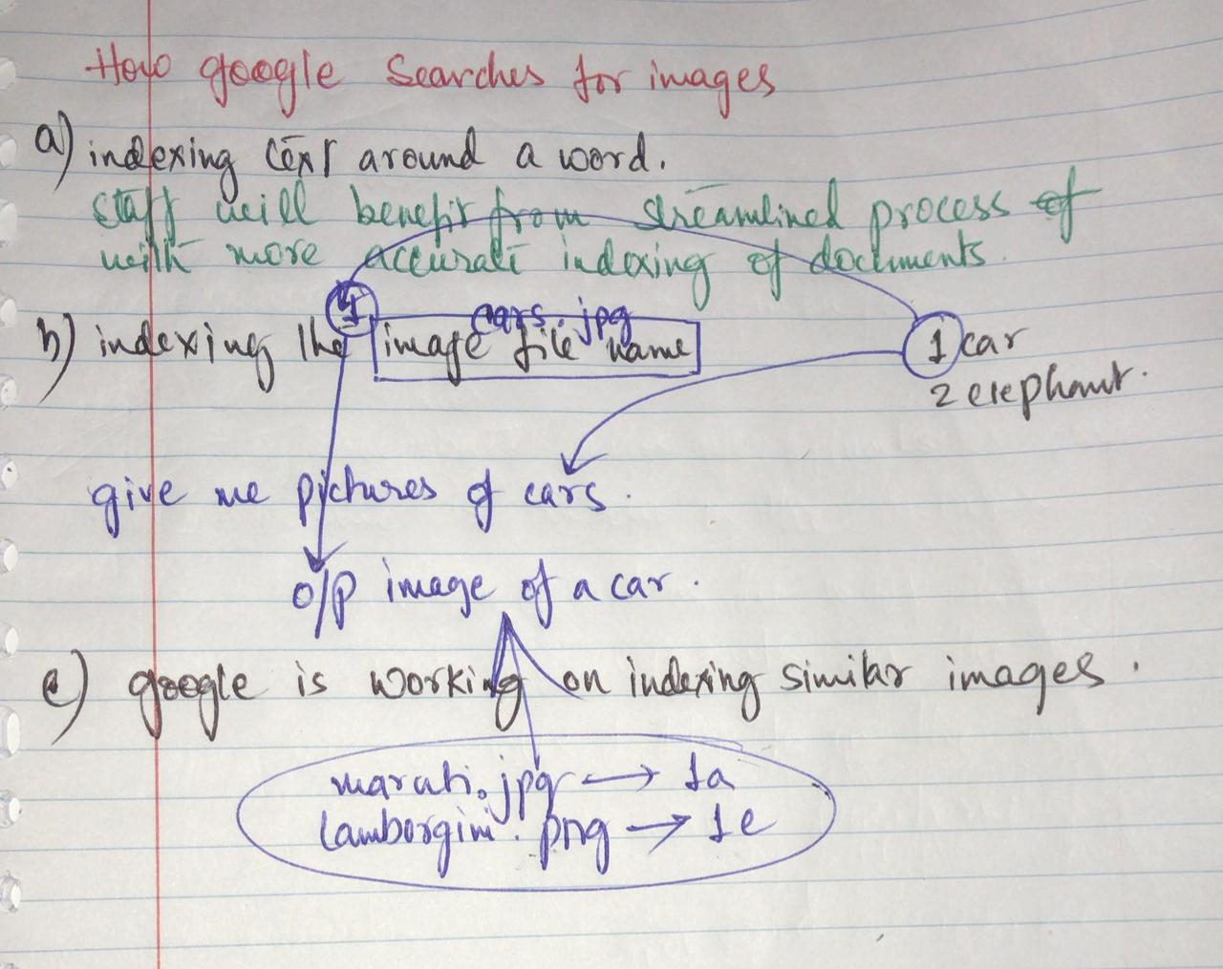

[**Nitin Thokare**](https://www.quora.com/profile/Nitin-Thokare), Master of Comp. Science from IISc Bangalore(India), major in machine learning.

[Answered September 18, 2013](https://www.quora.com/How-does-a-Google-image-search-engine-work/answer/Nitin-Thokare)

Originally Answered: How does google image search engine work?

There are two ways to do this.  
1) Indexing the text surrounding any image and matching it with the given query. If query matches, the corresponding linked image is retrieved. This is what is used by most search engines.

2) Going ahead, in addition to linking text surrounding an image to that image we can link all visually similar images to that image with the same text.

e.g. consider an image/photo Img1 on any site with it's surrounding text Txt1. And lets say there are some other images Img2,Img3,Img4 etc. which may or may not have text but their (visual) content matches with the contents of Img1.

Now for given query, if Txt1 is a good match, the retrieved result can contain Img1 in addition to Img2, Img3, Img4, etc.

This is just one factor in addition to many other like matching query with text, features used to represent an image, page-rank of page containing an image, relevence, indexed database size available with search engine, etc.

Huge indexed database availability with Google is one of the reasons why Google can give you best results.

[**Nick Bloomfield**](https://www.quora.com/profile/Nick-Bloomfield-2)

[Answered March 23, 2017](https://www.quora.com/How-does-a-Google-image-search-engine-work/answer/Nick-Bloomfield-2)

Originally Answered: How does Google image search engine work?

I think Sam has provided a pretty comprehensive answer and who am I to contradict a Google god!

However he has not dealt with perhaps the main aspect of your query which is language.

I have made various different language websites and don’t know if google will attribute the characteristics mentioned by Sam in the language of the country in which the search takes place. i.e. if you are looking on google france and put in chaise meaning chair will it only come up with images that are tagged with that in the original language or will it carry out any translation?

I’ve just carried out a brief search and it would appear to be language specific. Not a guarantee but it would appear that the enquiry language is relevant. For example if you input chaise on to uk google it will come up with predominantly chaise longue.

[[](https://www.quora.com/profile/Mahe-G-4)](https://www.quora.com/profile/Mahe-G-4" \t "_blank)

[**Mahe G**](https://www.quora.com/profile/Mahe-G-4), studied at University of Sydney

[Answered July 26, 2018](https://www.quora.com/How-does-a-Google-image-search-engine-work/answer/Mahe-G-4)

Google Image search working with the machine learning technique. ML is match pixel by pixel with indexed images and then give the appropriate result

No use of Name for sure…

Example

I download a dog image and save with cat.jpg but still i got the result related to dog appeared in Image

[**Blogger Helper**](https://www.quora.com/profile/Blogger-Helper), FA High Traffic Websites & Keyword Research, Govt Senior Secondary Public School (2017)

[Answered April 1](https://www.quora.com/How-does-a-Google-image-search-engine-work/answer/Blogger-Helper)

**Google's Search** by **Image is** a feature that uses reverse **image search** and allows users to **search** for related **images** just by uploading an **image** or **image** URL. **Google** accomplishes this by analyzing the submitted **picture** and constructing a mathematical model of it using advanced algorithms.

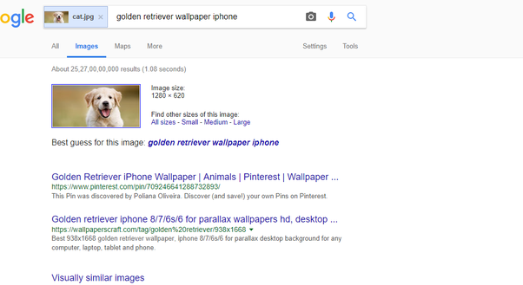

[**Jay Jarrell**](https://www.quora.com/profile/Jay-Jarrell), I am currently a writer for Quora.

[Answered July 1, 2018](https://www.quora.com/How-does-a-Google-image-search-engine-work/answer/Jay-Jarrell)

Pictures have a dataset of descriptive fields called metadata. These fields can contain qualitative, quantitative, locational or any other sort of descriptive attributes. Information can also be “tagged” into the file by real-time usage by various users. Google would likely prioritize and sort the images based on how many times the file has been viewed combined with the accuracy of the data fields to return the images in an applicable required way for the user searching for the images.

1.human hand annotated structured data

2.a.views:- let’s say user scrolls down a set of 50 images to admire everything about a particular picture of a particular topic

2.b.accuracy of annotated structured data